TANGATA MAHI PAI PILOT

Introduction:
This report records the seminal steps in a pilot community action project “Tangata Mahi Pai” which was designed to counter anomie amongst often marginalised community members and halt their downward spiral into mindless intoxication. It arose from a need to build community resilience against methamphetamine and other intoxicants identified through a regional survey (Hawke’s Bay) undertaken by the Department of Internal Affairs regional community advisors.
The project was primarily based at a small peri-urban Maori community Waiohiki. Waiohiki sits on the Tutaekuri river under the shadow of the ancient pa site Otatara. It hosts a marae and a large arts village. It is conveniently located between Napier and Hastings and is easily accessible on bus routes.
Tangata Mahi Pai (TMP) speaks of a person using their time well, and doing good things. It is rooted in strength based theory. Strengths-based community action emphasizes people's self-determination and inherent capabilities. It views community members as being able to be resourceful and resilient in the face of adversity.
The TMP project doesn’t differentiate between those who join the programme to recover their equilibrium and those who come to contribute their skills and energy as volunteers. The underlying belief is that when people use their time positively and constructively this will help build community resilience against social ills. In this instance, the primary prevailing social ill is drug-related- harm, specifically arising from the use of methamphetamine, synthetic cannabis and alcohol. There are other areas that the project has potential to help, for instance as a way to ward off depression as a result of unemployment or retirement and being at a loose end, and other manifestations of mild mental illness that benefit from the production of endo-morphine through physical activity.
The TMP project was enabled and supported by Hawke’s Bay CAYAD (Community Action Youth and Drugs) kaimahi, Suni Marston, Mane Adams, and Denis O’Reilly through referrals, worker supervision, supply of transportation and through use of the CAYAD Community Action Fund to fund tools and equipment. The project was managed by Laurie O’Reilly.
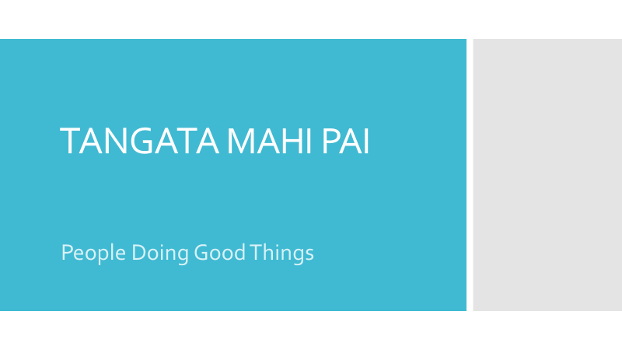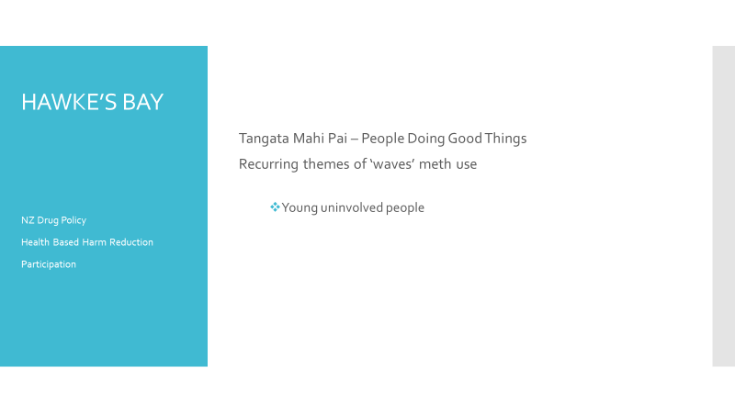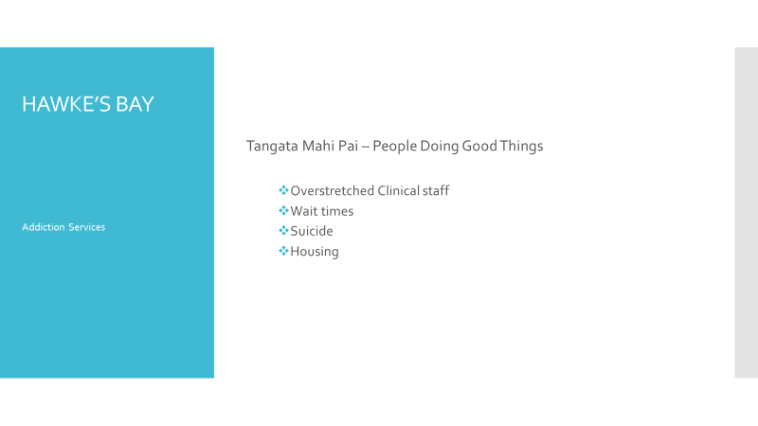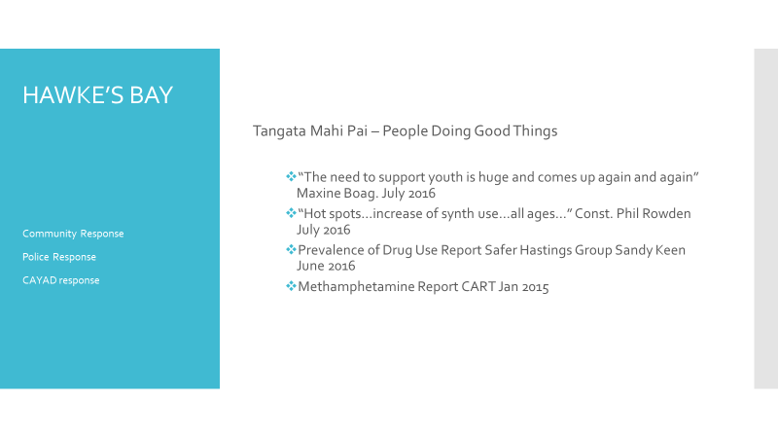Power 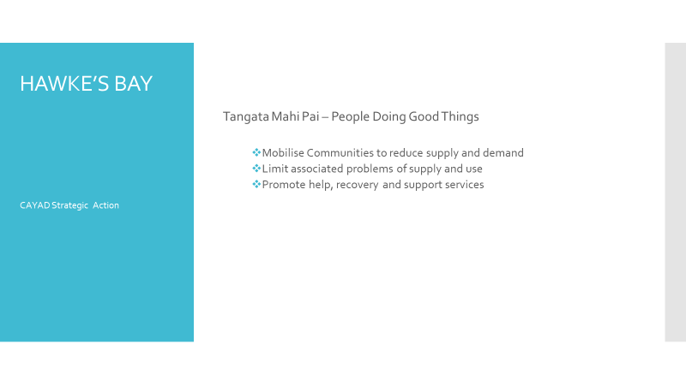
Power Point Presentation for Original Stakeholders.
The core idea was to provide a non-clinical daily programme of positive activity covering the continuum from outside manual labour through to the creative arts and community events. TMP was to be available to people, particularly those recovering from or encountering alcohol and drug issues, and or depression and self-destructive and self-defeating behaviours. We envisaged that we would get referrals from a broad community network. The belief was that by supporting people into doing positive “things” for themselves and for the community, would help to improve their wellbeing and make them more resilient to adversity. We saw those “things” as being activities across conservation, cultural activities, creativity, and caring for others.
For those participants with more serious addictions to intoxicating substances the longer-term objective was to develop an integrated process through which help seekers who required clinical support could be put through a “triage” type process whereby they would be referred to appropriate AoD providers. This service was to be predicated by establishment of a “barefoot counsellor” work -force comprised of both formal and informal community workers. This workforce was seen to be the core channel for referrals. The idea was to provide these para-counsellors with a mental health and addictions 101 type course so they “know what they don’t know” and recognise when they need to refer people on to a clinician rather than simply give a metaphoric cuddle and cup of tea. It’s a good idea but a way beyond our resources to establish.
Those who didn’t need immediate attention or require clinical help were to be provided with skill and spirit-enhancing activities as outlined above.

Outcomes
Community events included:
Omarunui 150th Commemorations https://www.youtube.com/watch?v=2jMz0u94JkA
Hosting the Ten Tenors https://www.youtube.com/watch?v=fV0W-1NeG7A
Hosting and supporting Paenga Sea Walls Project https://www.facebook.com/aaiAotearoa/videos/1174340339354715/
Organising and staging Pat Magills 90th Birthday https://www.youtube.com/watch?v=O3Zaq9MKeA0
Support of Te Matatini Festival 2017 https://www.maoritelevision.com/haka/te-matatini
Work activity projects included:
- Waiohiki Marae Rebuild
- Fruit and vegetable cultivation at the Ngati Hinewera maara kai
- Maintenance at the Waiohiki Creative Arts Village; and
- Eradication of Old Man’s Beard on the Tukituki River.
A brief description is provided of each of these activities.
There were 24 participants (6 female, 18 male) aged 17 – 51 years of age. Six participants were referred to AoD and/or mental health service providers. Four have taken up study or training. Eight are in full time employment. Four participants did not have addictions or had previously recovered from drug-use and simply wanted to give help rather than receive it.
Overall there was a significant impact. Besides the positive impact of staging or supporting community events, and the completion of practical work tasks, a group of heavy users of synthetic cannabis have now broken their habits.
Similarly, an interconnected family group living in close proximity to each other are now no longer using methamphetamine.

What did we learn?
- Broadly speaking, based on participant feedback, observable reduction in drug-related harms, and re-engagement in employment and training, the provision of a daily programme of positive activity is an excellent entry point for help seekers to come back into society and potentially into the workforce.

- Voluntary community activity is no longer a matter of simply getting stuck in to physical work. OSH rules mean that a project site effectively becomes a work site. Accordingly work safety rules and liabilities apply and this can have heavy cost implications to meet compliance.

- Significant funding is required for the type of project we aimed to establish. Because our idea sits across various governmental streams including criminal justice, health, and employment, there is no easy to access funding source.

- Both the synthetic user group and methamphetamine group had a strong enabler in their group that was able facilitate the groups drug supply thus maintaining and fuelling the addictions of the group. The success of the TMP programme can in a large part be attributed to being able to convince and facilitate each enabler not only to overcome their own personal addictions but also to help and support others around them to overcome their addictions.

- Addictions, their driving forces, and the recovery from addictions, is a complex, multi-faceted issue. Our aspiration to explore the possibility of establishing an AoD non-clinical help-seeker engagement and triage type service was premature. Such a service needs a strong relationship with a range of AoD providers. The nature and deployment of clinical service provision across Hawke’s Bay does not easily lend itself to easy access to clinical assistance.

Calendar
We originally aimed to run TMP in three sequential ten-week blocks more or less lined up with the school terms. We thought that there was merit in taking breaks in the programme and declaring victory on a regular basis. It would allow programme management to take a breather and reassess progress and make changes as deemed necessary. It also allows participants to swap round and try new things. As it emerged the programme was much more ad hoc and was driven by participant needs rather than organisational needs.

Numbers
We believed that for a start we would kick off with around 20 participants. We thought that, depending on how we were going and factors such as the presence of volunteer leaders numbers could substantially increase, however, we aimed to start with twenty per trimester. In the eventuality we had 24 participants and that number seems to be about right. They were not all contemporaneous. Our lack of ability to fund supervisory staff meant that the HB CAYAD were burdened with the responsibility of supervision for most activity apart from Waiohiki Marae and to some degree the mara kai.

WHAT ACTUALLY HAPPENED?

Omarunui
We kicked off in October 2016 with a team of seven. Our first project was the Omarunui Commemorations. Using tractors and mowers we cleared the area around the Omarunui Reserve and created decorative palisading and carved pou. The team members also hosted around 200 guests. It was an excellent and very moving event:
The Omarunui commemorations was probably one of the more significant events. It definitely was. Being able to be part of that and being given the responsibility to go out there and put up some palisades and be given creative leeway – although we had instructions and were given the tools and materials – and also the freedom to be able to say “well we could do it this way or do it that way”. It was awesome when the crowds came. It was an excellent experience it really was. And in saying that meeting up with the local guy from around the corner who allowed us to borrow his tractor. That was really cool to see another member of the community to come in and build a relationship with them. it was cool. TMP Participant

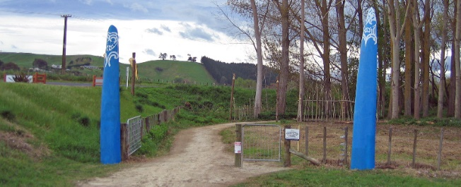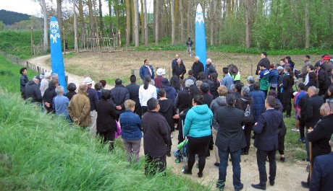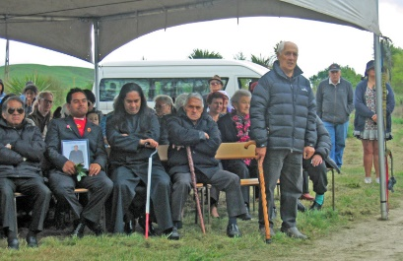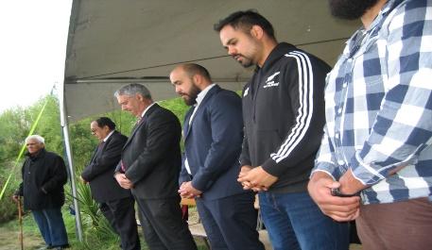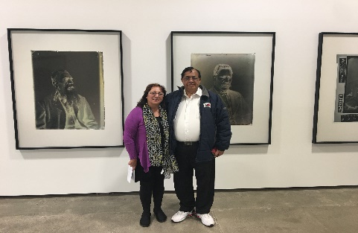
Entrance way at Omarunui Reserve: Manhuhiri arrive: Relatives of those buried at Omarunui: Mana whenua and Mayor Yule: Jono Rotman’s “Omarunui” photographic exhibition.

Branding
Reflecting on this work at Omarunui and how things were for participants we came to the conclusion that we needed to consider some branding. We also recognised that effectively we were providing a workplace and that we needed to take into account the need for safety equipment and high viz clothing. In terms of branding we looked for a friendly inviting image.
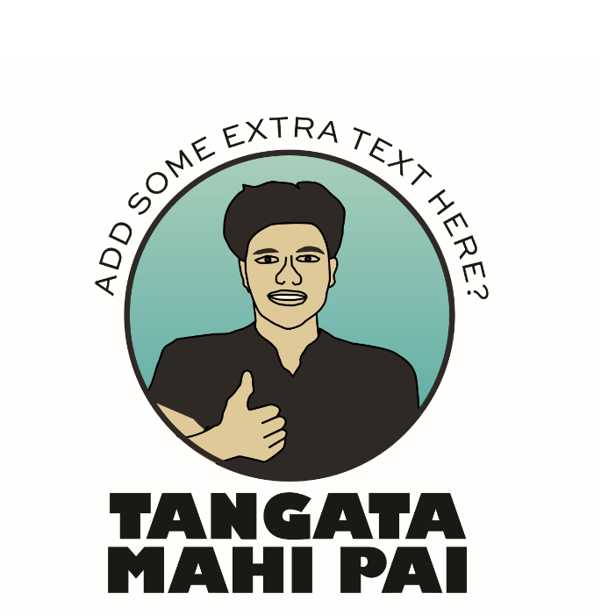
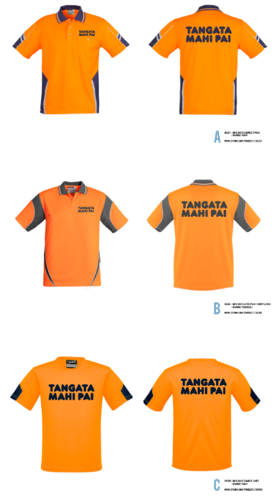
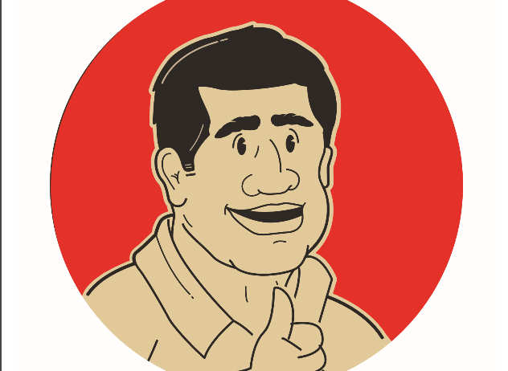

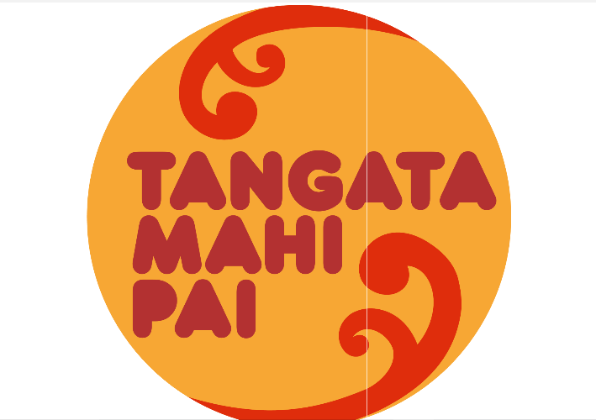

We decided to forego the image and settled on a high viz shirt with simple text. The provision of a uniform type piece of clothing not only helped us meet our safety obligations but also became an incentivising device.
I put the tangata mai pai shirt on every morning because it gives a sense of excitement TMP Participant
Starting on the programme gives you a sense of purpose in the morning. Getting up, putting on the shirt, getting picked up going out into the local community, which is another positive. Getting out there and making a difference. For myself it was taking my mind off needing or relying on it [synthetic cannabis] during the day. Getting out there and putting what I can do to work. And seeing the benefits of it not only for myself but the benefits of doing that work and the benefits for the community and being a part of the community. TMP Participant

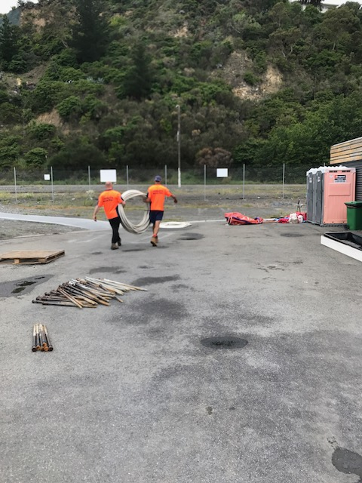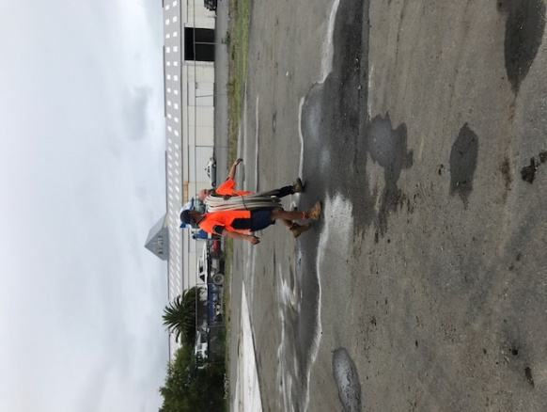

Te Matatini
The next major event was the Te Matatini Festival held in Hastings. This was a huge event with over 60,000 people attending. Our Tangata Mahi Pai team helped in the erection of the geodesic domes used for hosting attendees – this has led to employment opportunities for two of the team. The TMP team also set up a “time out” whare manaaki in the camping ground. This was to enable whanau members and children to have a place to go and mellow out away from the intense hustle and bustle of the event. This was a very popular offering. It is also apparent that being part of an event creates a sort of frisson amongst the work team
You get a sense of excitement for the outcome of the event…its more than the reward…for me events are a passion setting up an environment where people are enjoying themselves…setting up the event is like being part of the event itself…and people recognise you when you’ve got your high viz shirt on and people think they must be the crew they must have set this up…”this is awesome”…”this looks awesome”….”I can’t believe you guys did this”. And it makes you feel a power because you are part of the team, that crew that organised that, that got that to go. It was awesome like the Omarunui experience because there was a lot more media coverage than I had been prepared for. We did the work but then people from all over the place were talking about it…it was on a newspaper here it was on a blog there …it was on facebook and you were part of it. With Matatini setting up the campsite there were pictures of me and the boys all over facebook…people I didn’t know but friends who had tagged me in..”was that you at the dome?” It turned out great it was awesome…TMP Participant

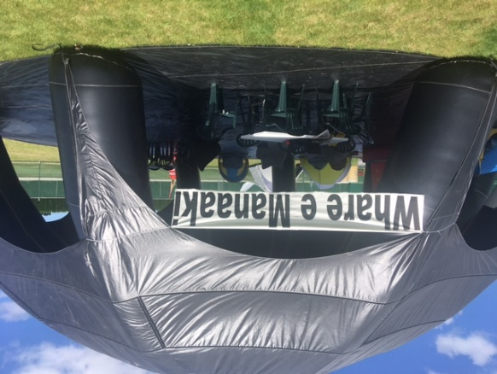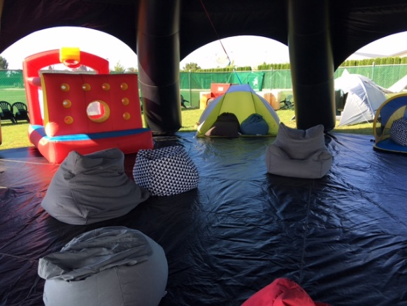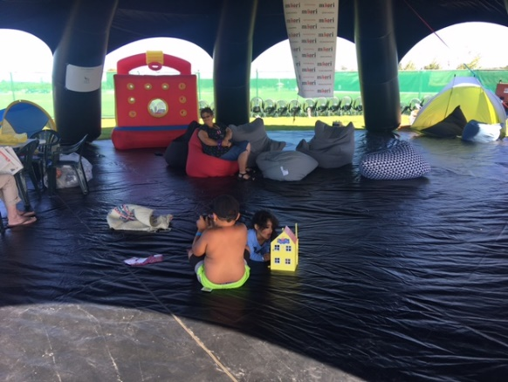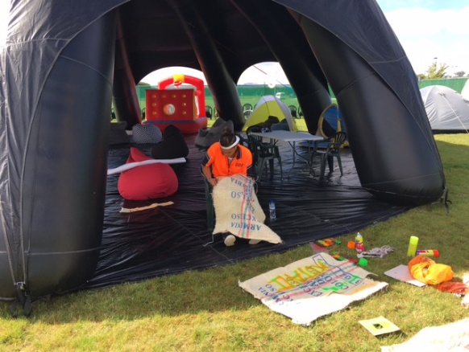
Whare e Manaaki at Te Matatini. Chill out space for whanau

Rural Fire Call Out Waimarama
When we were in the Tukituki area for the Old Man’s Beard eradication there was a large fire further down the river. It was huge and destroyed a house and had the potential to affect large areas of pine and other dwellings. There were helicopters and large numbers of fire personnel. Three of the team then became interested in voluntary fire service duty and undertook some training at Waimarama with the Rural Fire Service

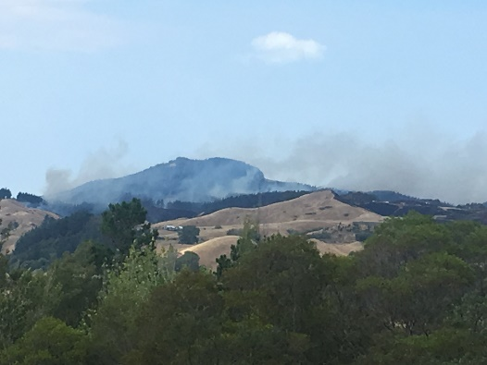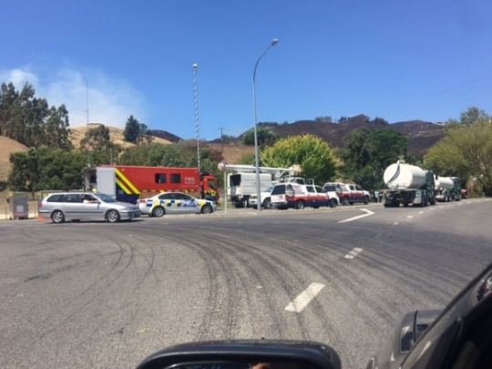

Waiohiki Marae Work
The Waiohiki rebuild is a $2.5 million-dollar project. Team members helped out with painting at Waiohiki Marae. There were some drawbacks in terms of our people being unskilled and so the finishing work was a bit rough. There is potential for less skilled input in the future. We are having a discussion with NZ Army and the Napier City Council have agreed to run Site Safe courses.

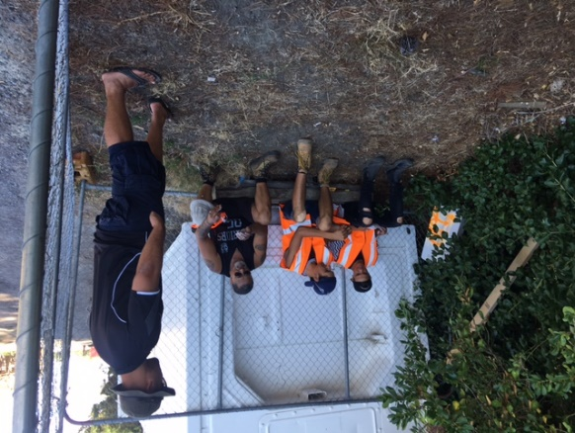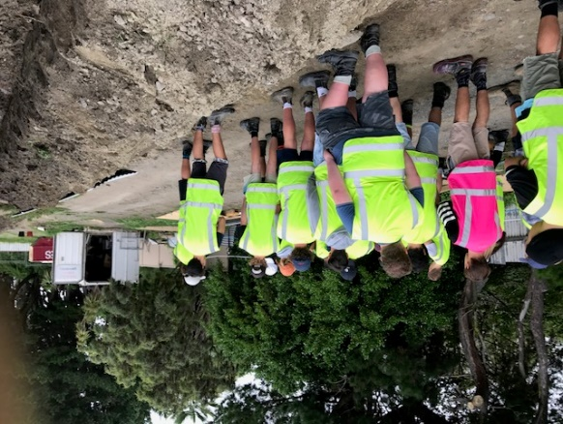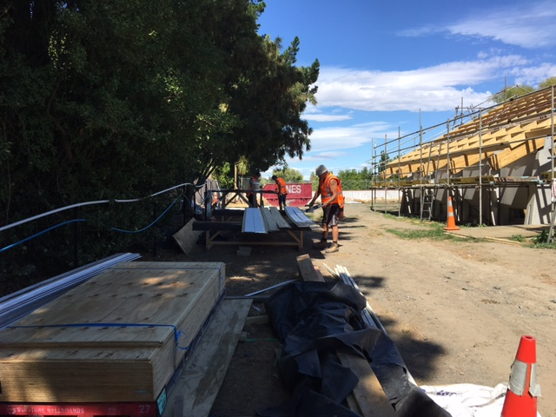

Maara Kai
The maara kai serves the whanau that live in the 10 houses of the Ngati Hinewera papakainga and other neighbouring households. The maara kai provides whanau access to organic fruit and vegetables for most months of the year. The maara kai is reasonably large. We have constructed vegetable boxes that a few of the papakainga households have placed around their houses. We have also planted numerous fruit trees in the maara kai around the houses.
We have found the maara kai is an effective way for individuals to re-connect with mother earth and nature. Nurturing and cultivating the land has spiritual and psychological benefits. This is particularly beneficial for those struggling with drug addictions and or depression. Maara kai encapsulates the whakatauki “Whatungarongaro te tangata, toitu te whenua. Ko te mana whenua, he mana tangata. Ko te mana tangata, he mana whenua”. As man disappears from sight, the land remains. If we nurture the land, the land will nurture us. As people become more conscious of their role in caring for their land and the environment, we have found that this has led to them making other positive changes in their lives, such as overcoming addictions, obtaining employment and adopting healthy lifestyles.

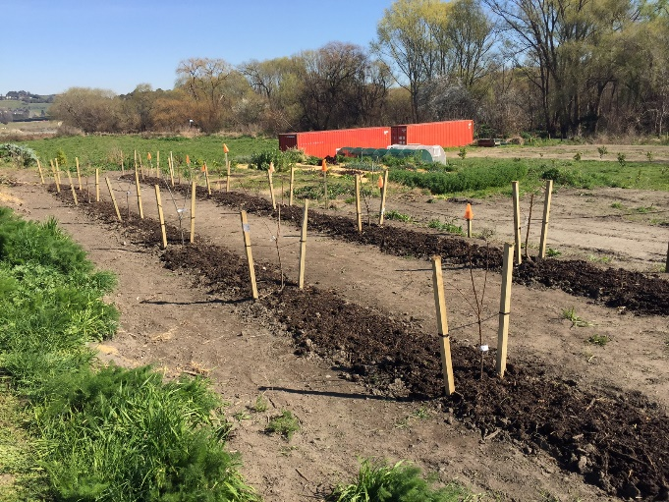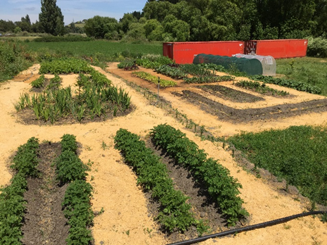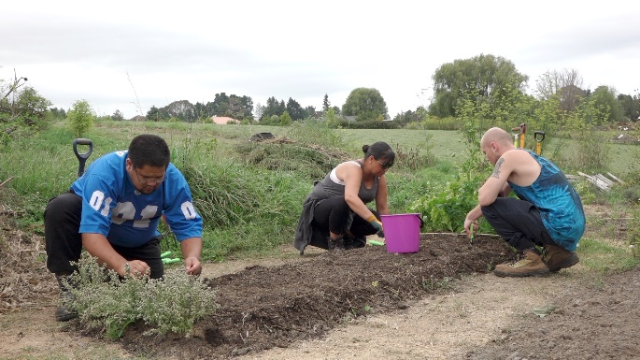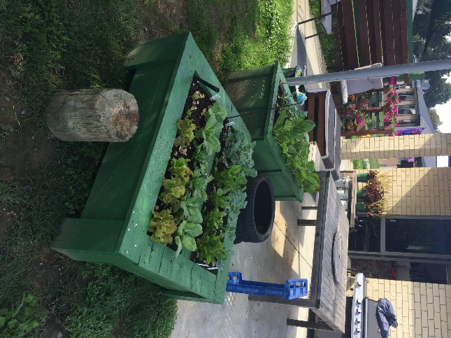
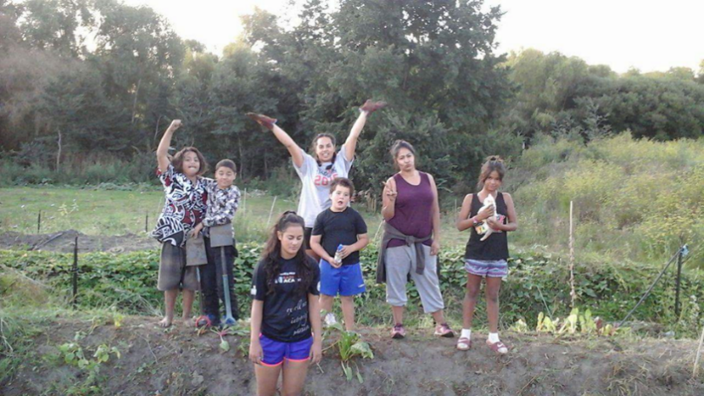

Creativity
Rage designed an awesome banner for the Otatara class at Henry Hill School and used his graffiti skills to create banners with uplifting positive values. He and is mates also helped out with the Paenga Seawalls project including the Tutaekuri bridge public art.
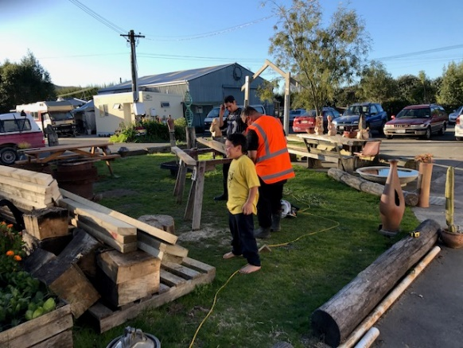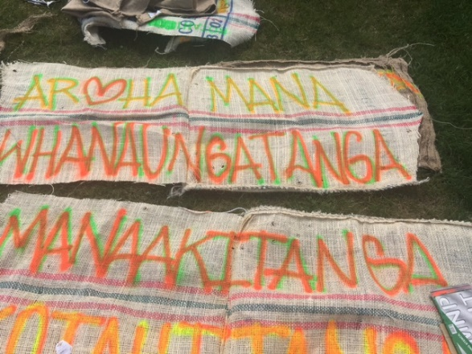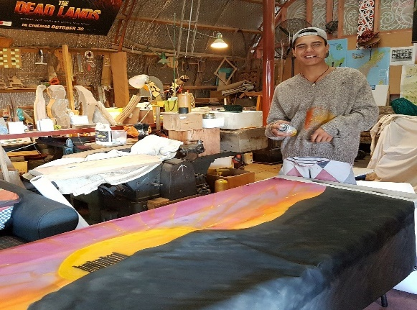
Rage preparing his banner for Henry Hill School; Mane and mokopuna at Waiohiki Arts Village; Rage’s positive values graffiti; Rage’s Henry Hill banner at Arts Village

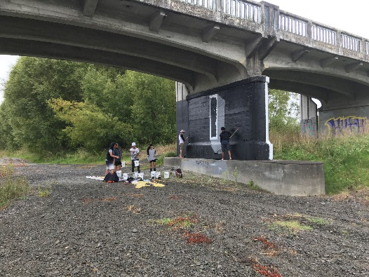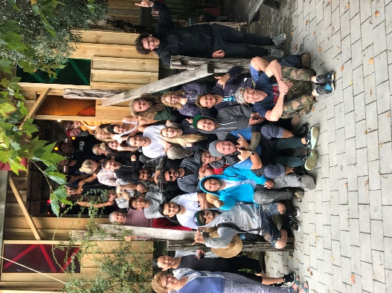
TMP team working on Tutaekuri bridge. The entire Paenga Seawalls team

Conclusion
This project was worth undertaking. It holds promise but requires significant funding. The OSH regulations and costs of equipment hire and supervision mean that it is probably best as a joint effort undertaken with a Local Authority. We will pursue this possibility.

Denis O’Reilly

The literature is plethoric. See Barwick, H. (2004). Young Males: Strength-based and Male-focused Approaches, A Review of the Research and Best Evidence. New Zealand: Ministry of Youth Development; Maruna,S. & Le Bel, T. (2003) Welcome home? Examining the re-entry court concept from a strengths based perspective. Western Criminology Review 4 (2) 99-107; Walker, S. (2016) The teaching of Māori social work practice and theory to a predominantly Pākehā audience. Aotearoa Social Work Vol 24. No 3-4.

